Homework PACKET 8

iDAHO pUBLIC dRIVER eDUCATION

URBAN & FREEWAY DRIVING

URBAN (CITY) DRIVING
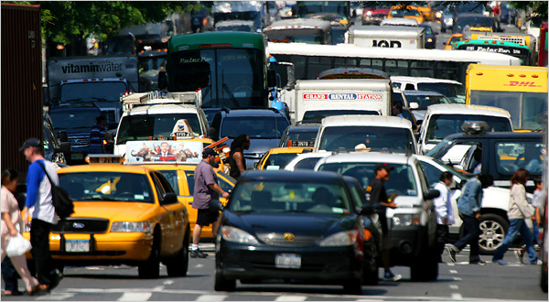
There are more hazards per mile in city driving than anywhere else, requiring much quicker reaction time and a greater understanding of Zone Control. You will come across more cars, busses, trucks, and pedestrians in the city and there are more signs, lights, and road markings here too.

Busy city driving can push all your abilities to their limits. IPDE and Zone Control are required to take it all in.

There are two things you can do to better handle all the hazards of urban driving. One: slow down! Hazards come at you slower if you are driving slower. You will have more time to IDENTIFY and PREDICT what is ahead and around you. Two: make sure your following distance is at least 3 seconds. Most following-too-closely collisions occur in busy city traffic but could have been avoided with a proper following distance. You may be the only driver keeping a safe following distance but it may prevent a number of collisions.

Other tips include looking beyond the vehicle in front of you. You can look over, around, and even through vehicles to get a better view of signs, lights, and other objects.

Be alert in areas where sudden stops can occur. Keep your attention on the driving

Task and not on mobile devices, friends, or internal vehicle controls. If you need to take your attention from the road for a moment, like glancing at an address written down or changing the radio station, first make sure your front zones are stable and open and increase your following distance. Lower your speed. And of course, if you have a passenger, ask them to help while you continue to keep your attention on the road.

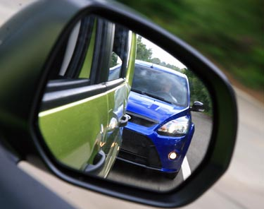

TAILGATERS

What do you do when someone is tailgating you? Do you slam on your brakes? Speed up? Slow down? Show a little road rage?

A tailgater is dangerous for you as well as for him or her. Handling this situation responsibly is important. First, increase your following distance between you and any traffic in front of you. If they suddenly stop you will have more time to react and prevent a collision between you and the tailgater. Second, move to lane position 3. This communicates to the tailgater that you see them and helps them see around you better. This also might help them to pass you if that is their intention. Third, tap your brake lights and signal early before you slow or turn to give the tailgater time to react. And fourth and last, change lanes or pull over if nothing else is working. To reduce risk and stress, your best defense is to avoid tailgaters.

HOMEWORK PACKET 8

Idaho public driver education

brake. This is called “riding the brake” and can wear your brakes out faster and confuse drivers behind you because your brake lights will be on.

Heavy traffic makes some people crazy. They have little patience and they become angry. Many impatient drivers continue to swerve between lanes, always looking for an advantage to get ahead. In Idaho, this is considered “aggressive” driving and is illegal. Studies also show that driving 5 mph faster than everyone else will only save you, at the most, 4 minutes over a 10-mile stretch of road. If you find that you are constantly 4 minutes late for school or work, try getting up or starting your commute 4 minutes earlier.

LANE SELECTION

The left lane is usually faster than the right since vehicles in the right lane often signal, slow, and turn into businesses along the right side of the roadway. However, at times the left lane can be held up by vehicles slowing or stopping to turn left across busy lanes of traffic. Selecting the best lane is a constant process of analyzing the flow of traffic and choosing the smoothest lane.

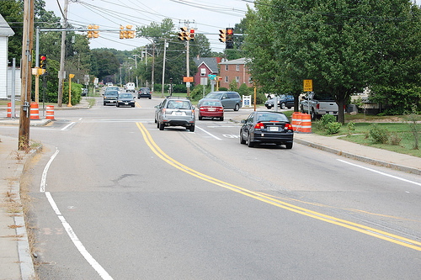
Knowing which lanes turn or continue straight is very important. Can these cars go straight here? Why?

ONCOMING TRAFFIC

Good drivers watch every vehicle coming its way on a two-lane road. If an oncoming vehicle suddenly swerves into your lane, knowing how to respond may help you avoid a dangerous or deadly collision.

On-coming vehicles may cross over into your lane for a number of reasons, including physical impairment (drugs, tired, emotional, sick, etc.), poor judgment, poor visibility, narrow lanes or a bridge, pedestrians or other obstacles in the road the driver is trying to avoid, or a vehicle malfunction like a tire blowout. If speeds are high – say both you and the oncoming vehicle are traveling at 55 mph, the combined impact, if head-on, would be 110 mph. Few can survive that, even with seatbelts and airbags in use.

If you see an on-coming vehicle swerve into your lane you should:
- Slow down. This will give you better control, more time to react, and will reduce the force of impact if one is unavoidable.
- Turn on your lights or honk your horn.
- Move as far to lane position 3 as possible.
- If necessary and your front right zone is open, swerve sharply to the right and aim for an open space to avoid the collision with the vehicle.

APPROACHING INTERSECTIONS

IDENTIFY and PREDICT traffic lights at upcoming intersections. Did the light just turn green? Then you have more time to get through the intersection. Has the light been green for quite awhile? This “stale” green light may change to yellow and red any moment. Be prepared. “Cover” your brake if there is any hint that you might have to stop quickly. Covering the brake is as simple as holding your right foot slightly above (but not on) the brake pedal. This could cut your reaction time and avoid a collision. Do not rest your foot ON the
HOMEWORK PACKET 8

Idaho Public Driver Education
One-way street clues:
- One-way street signs
- All moving and parked traffic point in the same direction
- Broken white lines separate traffic lanes

If you remember that you always should turn into the closest lane legally open to you – you will know where to turn onto a one or two-way street. And if you are stopped at a red light and there is no cross traffic – you may turn left onto a one-way street while the light is red.

Like all driving skills, traveling in busy urban areas requires practice and repetition until you gain the necessary confidence and experience.

What if you are taking driver education in one of Idaho’s many rural areas? Chances are you will not be able to practice some of the following skills and will have to do that later on trips to other cities:
- Traffic signals
- Merging lanes
- Shared turn lanes
- Freeways
- One-way streets
- Parking garages
- Busy parking lots
- Bus or carpool lanes
- 4-way stops
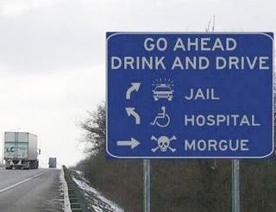
SPECIAL LANES AND STREETS

To help move traffic along better many cities have special lanes for busses and/or carpool drivers. It is illegal to drive in a carpool lane without having passengers in your vehicle with you.
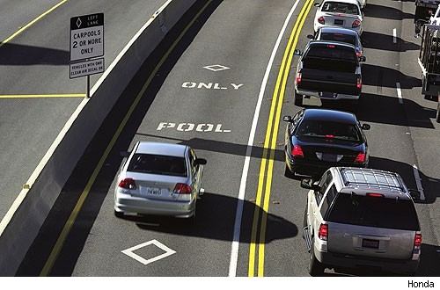
Bus lanes are typically lettered with the words “BUS ONLY” and no other vehicles may drive in these lanes. The SUV in the photo below is not obeying the law.

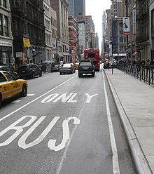

In Idaho many drivers are confused or fearful of the one-way streets found in some of its larger cities. Some streets even become a one-way or two-way street after passing through an intersection. The solution is to always watch for clues that define which way traffic must flow.

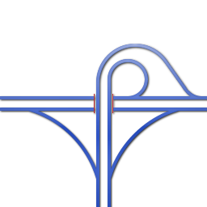
A trumpet interchange is used when a side road forms a “T” intersection with a freeway.

Safe freeway driving includes:
- Be well-rested for long trips
- Make sure your vehicle is safe for high-speed travel
- Concentrate on driving. Things can happen fast at higher speeds
- Cooperate with other drivers
- Stay alert by changing drivers and/or taking regular breaks on long trips

IDAHO FREEWAY LAWS

- Vehicles may travel at speeds up to 75 mph on rural interstates
- Heavy trucks must not exceed 65 mph on rural interstates
- You must slow down and, if possible, change lanes to protect police officers and their vehicles stopped on the side of the road.
- Bicycles may ride along the edge of Idaho freeways.
- No person shall stand on a highway for the purpose of soliciting a ride.
FREEWAY DRIVING

A freeway, also known as an “expressway” or “controlled-access highway”, is a high-speed roadway with no cross traffic, a barrier or median between opposing lanes of traffic, few or no pedestrians, mostly wide and straight pavement, and no traffic lights. Freeways can move a high amount of traffic great distances and at higher speeds than other roads.

Traffic enters a freeway by using an interchange. These come in a variety of styles depending on the terrain and room available.

A cloverleaf interchange has multiple entrances and exit ramps that resemble a four-leaf clover. The type of interchange allows driver to go in any of four directions.

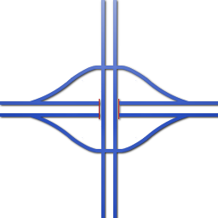

A diamond interchange is used when a road with little traffic crosses a busy freeway.

HOMEWORK PACKET 8

Idaho Public Driver Education
REVIEW QUESTIONS
HOMEWORK PACKET 8

NAME: _______________________________________ DATE: ____________

DIRECTIONS: Answer the following questions based on what you learned from the homework packet and chapter 7 in the Idaho Drivers Manual.

- There are more _________ per mile in city driving.
- Name the two things mentioned that can help you handle all the hazards of busy city driving:

- Name the four tips for dealing with tailgaters:

- If an on-coming vehicle swerves into your lane, four things you could do include:

- Name some of the urban driving skills and situations you cannot practice where you live.
- Name the freeway interchange that should be used in a high-traffic area where roads come in from all four directions.
- Heavy trucks must travel ___ mph slower than other traffic on Idaho freeways.

